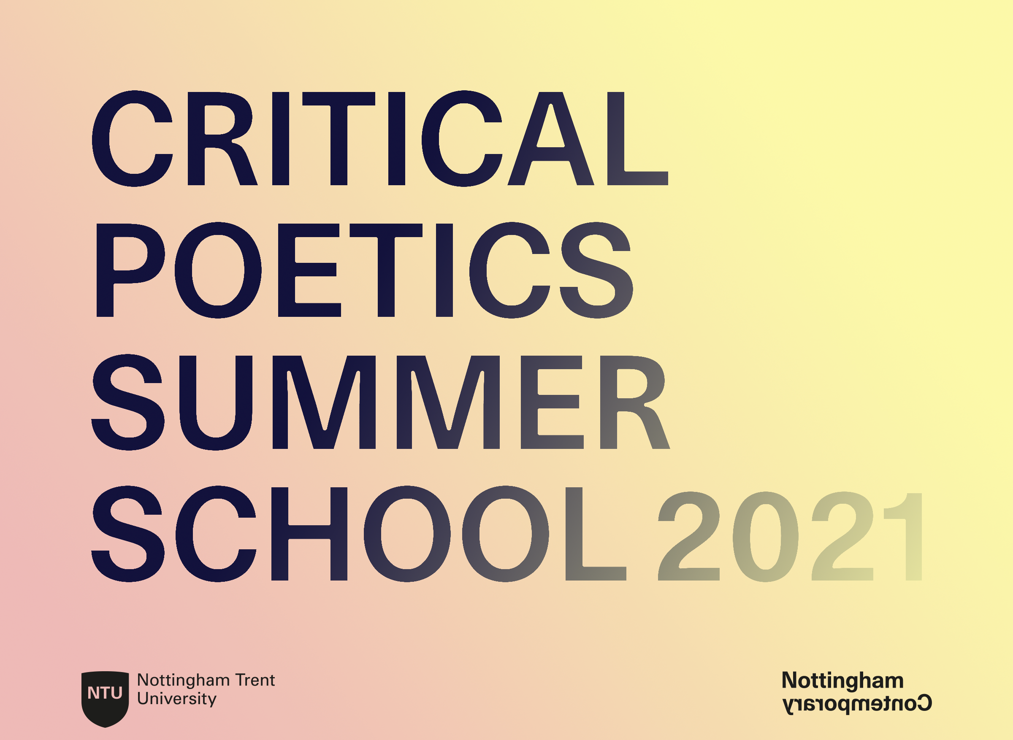
Critical Poetics: Care Of...
Summer School
Online, 25 June – 3 July 2021

Application Form

The programme for the 2021 summer school will be structured as follows:

Mornings: one-to-one sessions and time to work on your own material
Afternoons: critical-creative workshops
Evenings: public lectures/readings/performances

The programme is free to attend. By submitting this form, you are indicating that you commit to taking part in the full programme.

Name: ___________________________________

Email Address: ___________________________________

Please tick this box if you would like to be added to our mailing list: □

Please outline how you would benefit from the Critical Poetics Summer School and what you think you would be able to contribute to the discussions and activities (max. 200 words).

This year we will explore the subject of ‘care’, in its broadest sense. Please outline how and why your work engages with this theme (max. 200 words).

Please provide a brief biography. You may wish to use this space to tell us about any relevant publications or previous works (max. 150 words).

Please send your completed form to jack.thacker@ntu.ac.uk by midnight on Sunday 9 May 2021. Up to 18 participants will be selected to attend the full programme. Applicants will be notified of the outcome by Monday 24 May.

